**Aim: Hierarchical clustering in orange.**

Solution:

Open Application -> Orange -> Select new file

Select File -> double click on it ->Select the table from the file as iris.tab.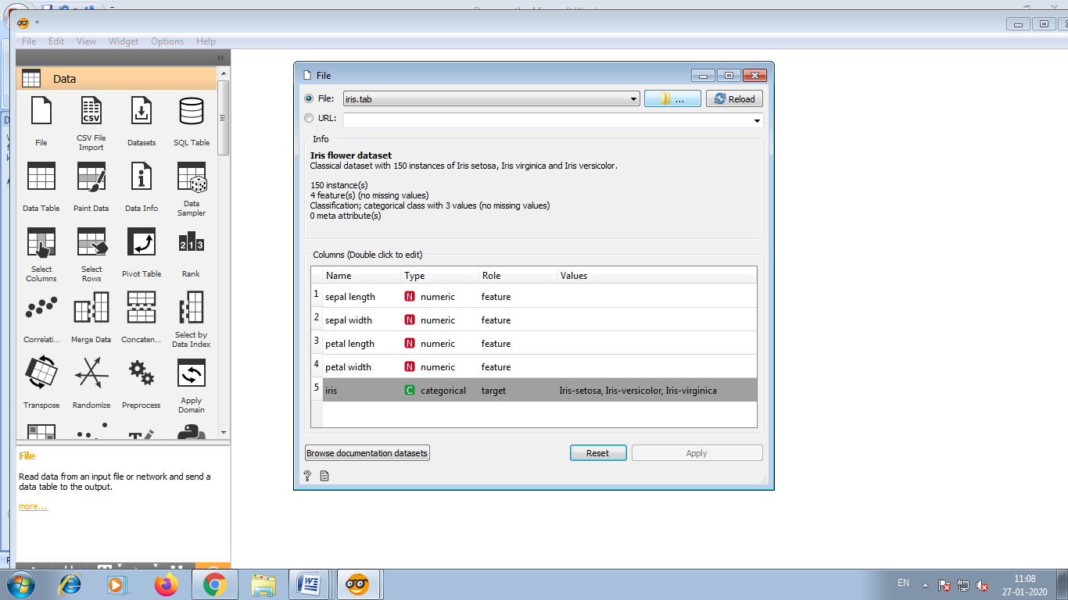

After selecting iris.tab, open it .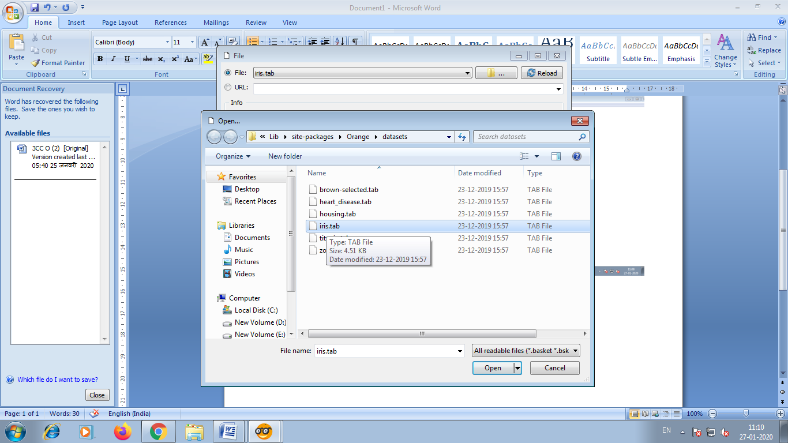

Directly close the current window as shown in below.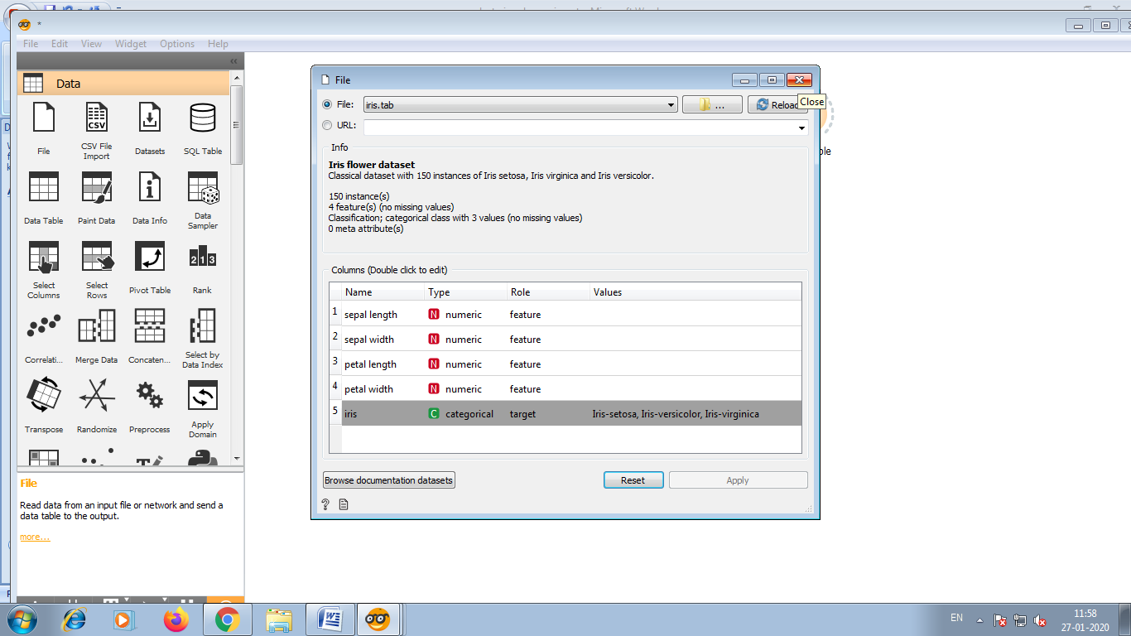

Click on the file and select Distances from the list.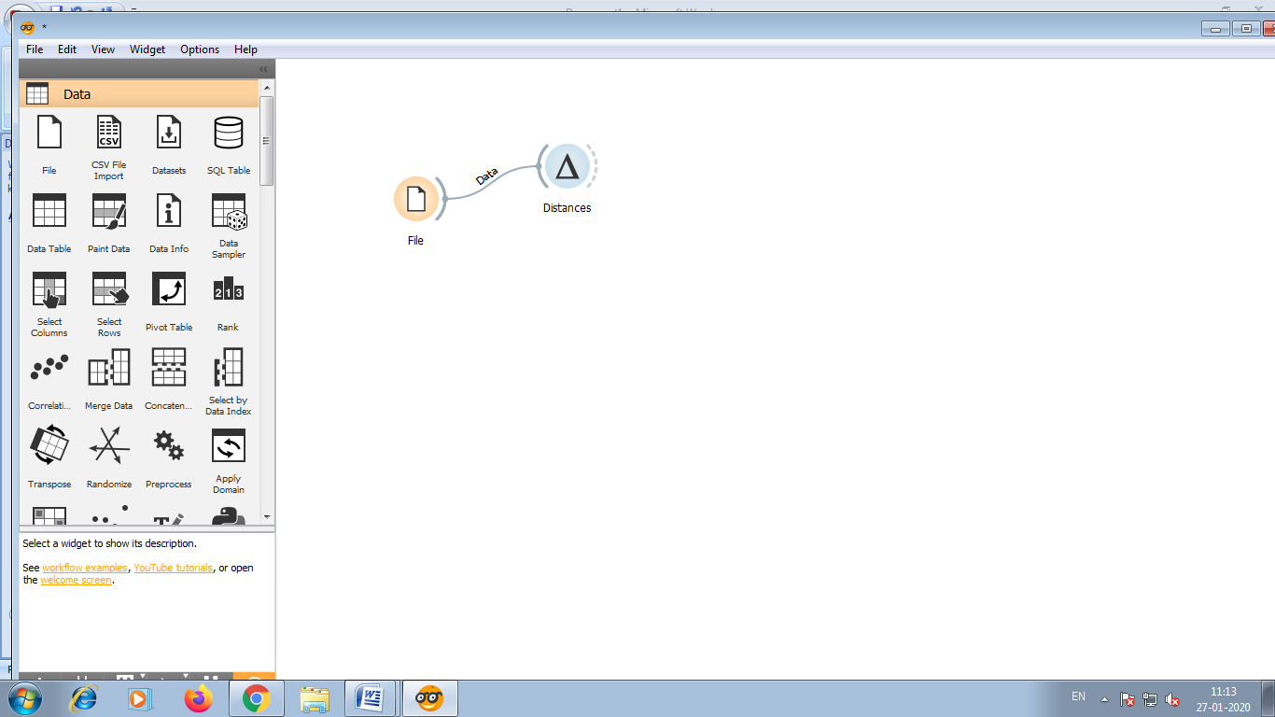

Again by clicking on distances select the hierarchical clustering .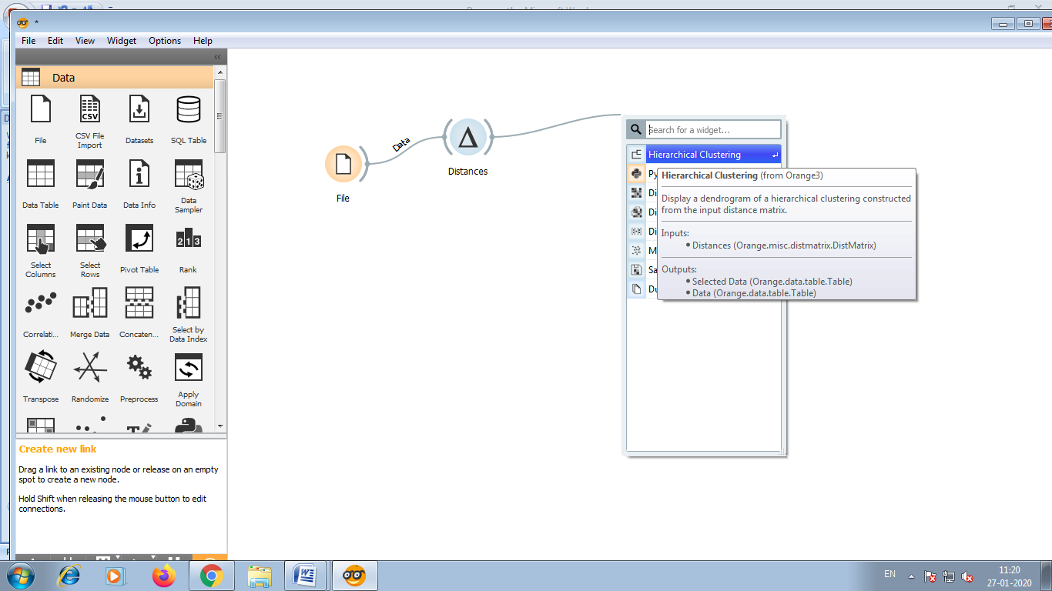

After selecting hierarchical clustering it look like this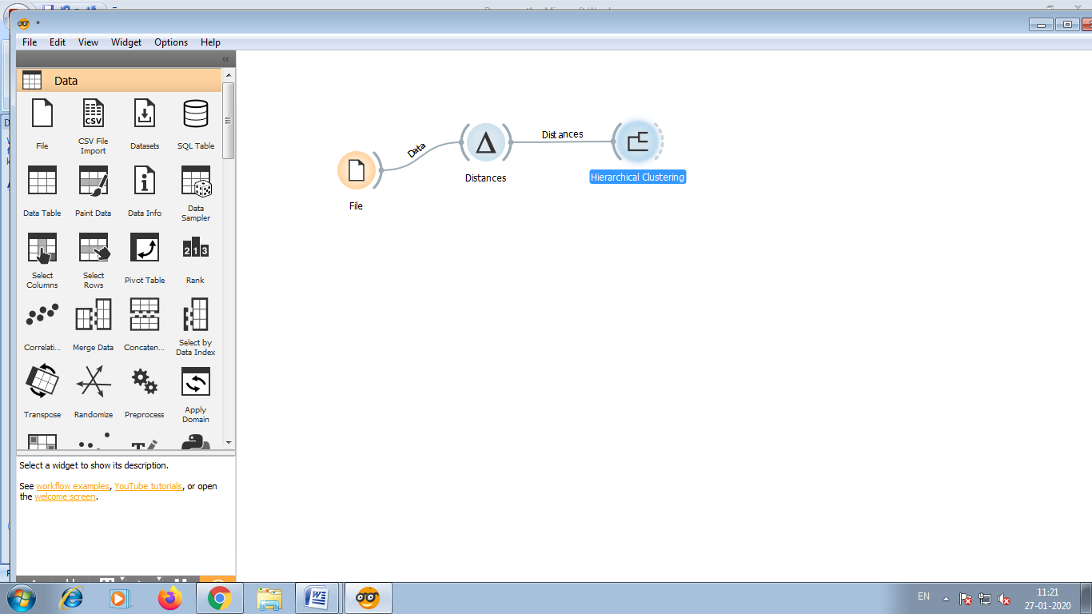

Now double click on hierarchical clustering, you will see the picture of hierarchical clustering.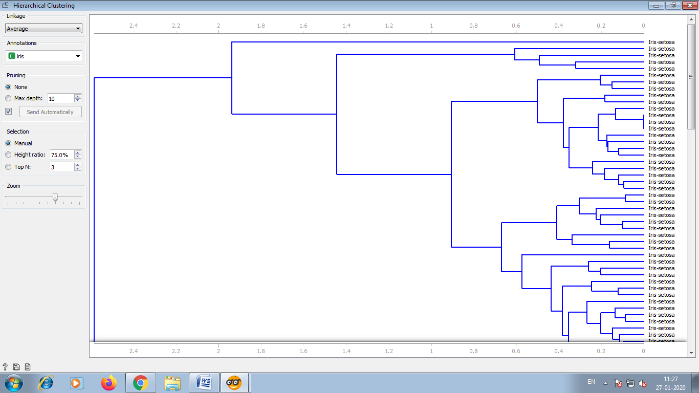

Now select the sub-cluster as shown in below.

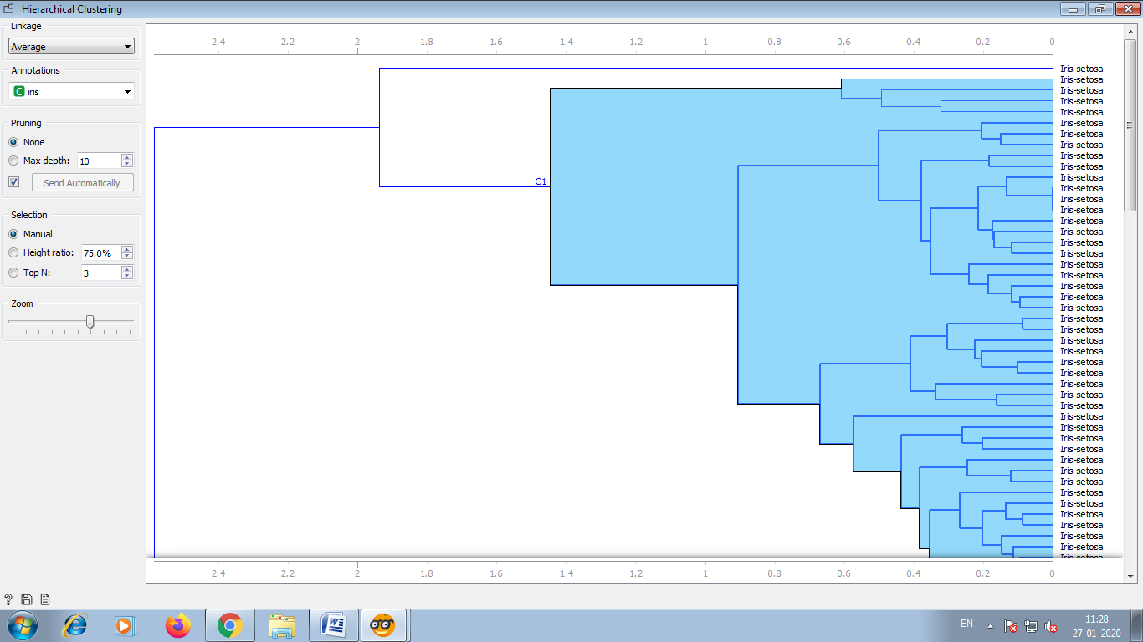

Now by clicking on hierarchical clustering select the data table.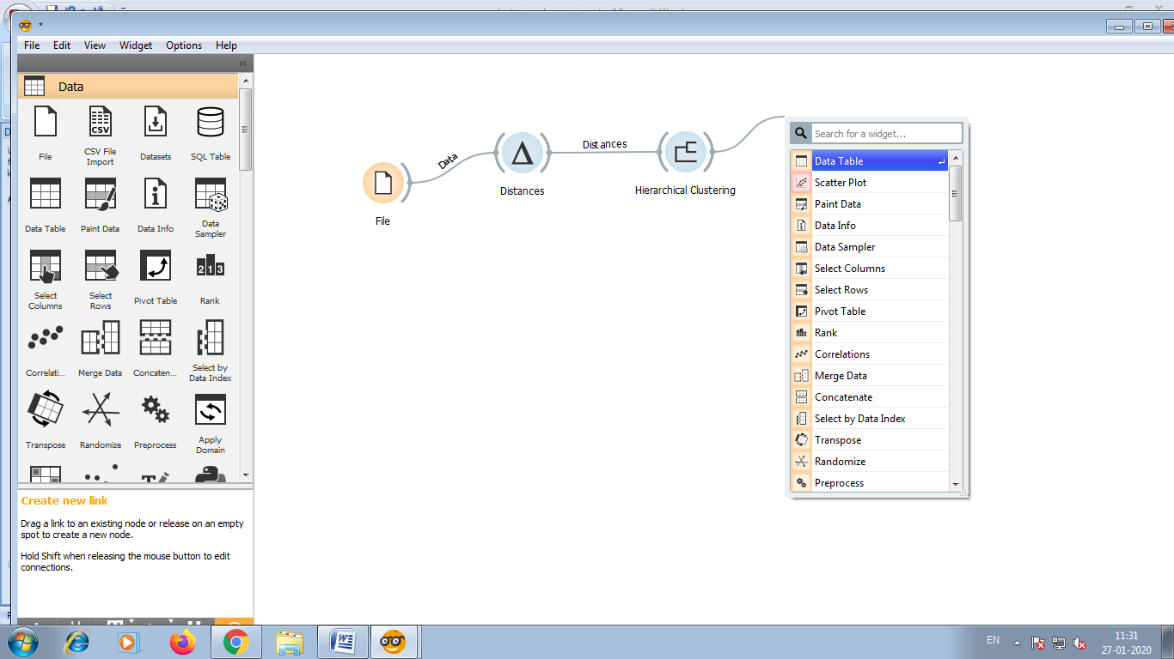

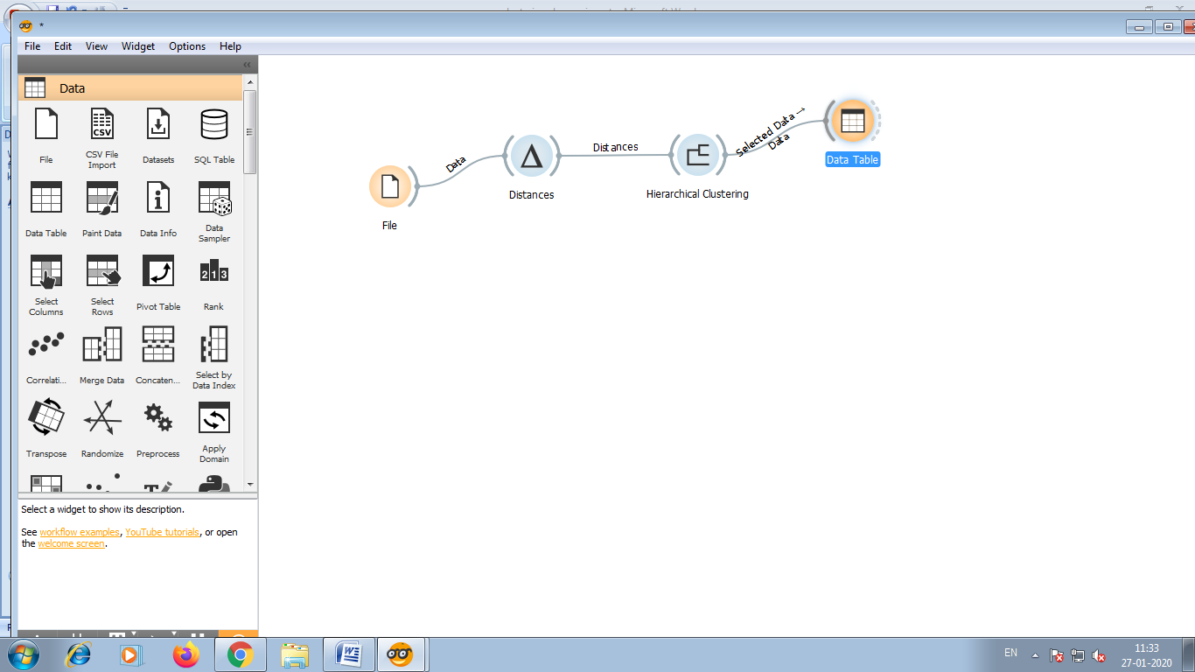

By double clicking on data table you will see the data which you have selected.

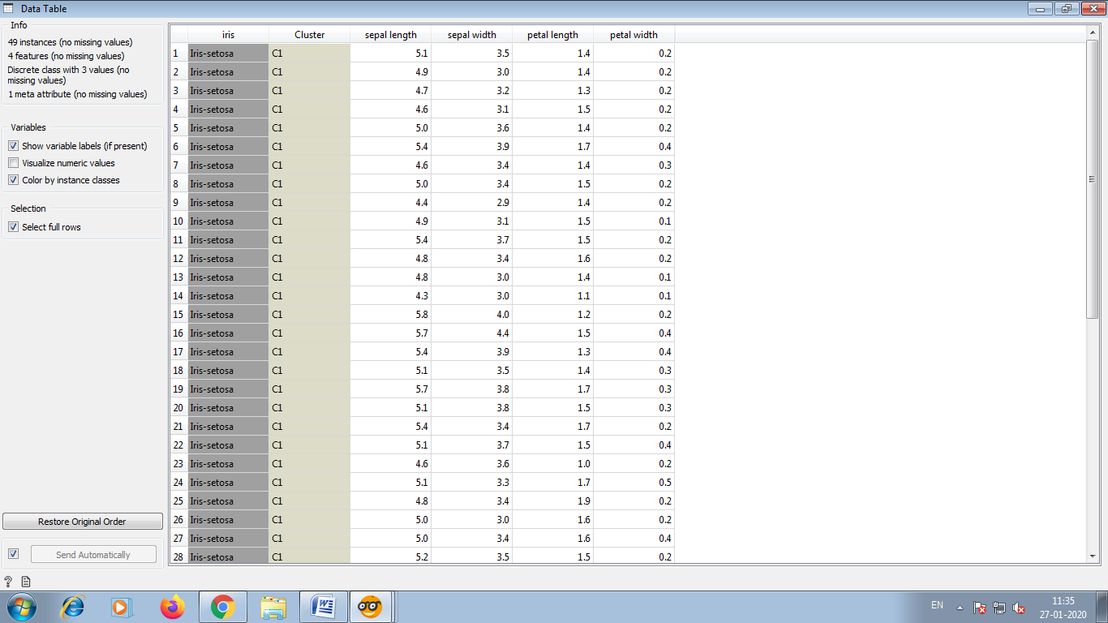

Now by clicking on file select scatter plot.

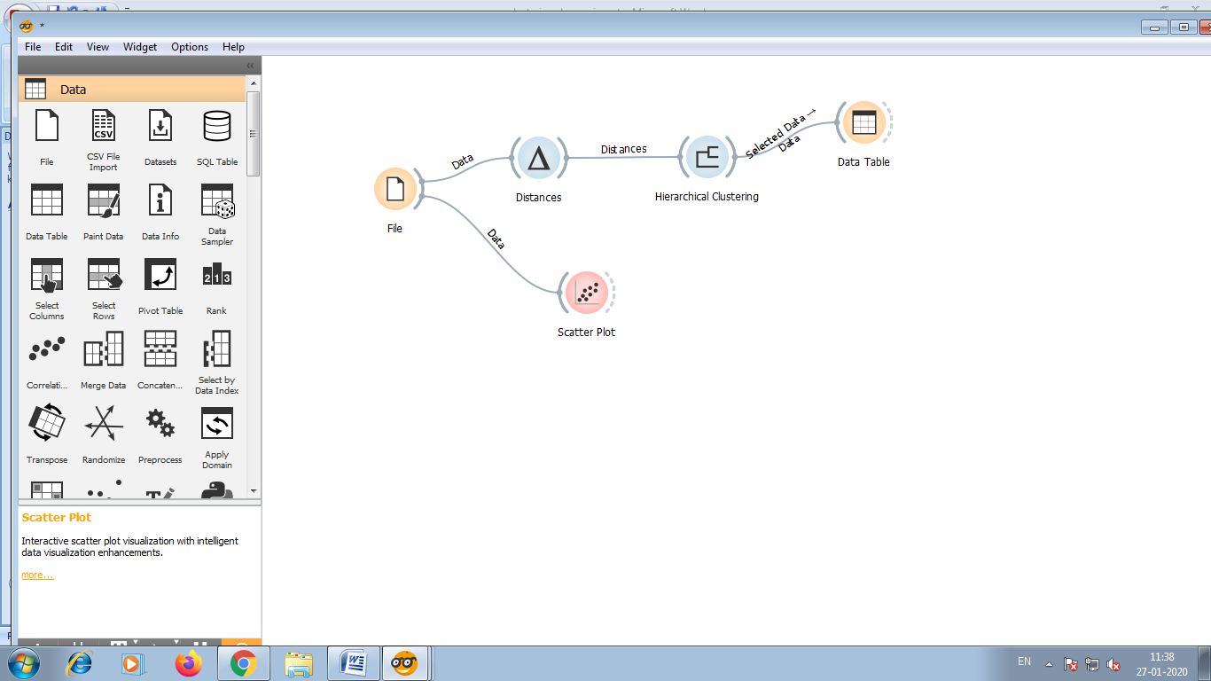

* By double clicking on scatter plot you will see the different colours , which shows the different type of clusters as shown in below figure.
* Cluster of Iris-setosa is represented by blue colour, Cluster of Iris-versicolor is represented by red colour and Cluster of Iris-virginica is represented by yellow green.

